SQL QUERIES AND OUTPUTS:-

1. Monthly trend of sales across all regions.
SELECT
YEAR(Date) AS SalesYear,
MONTH(Date) AS SalesMonth,
SUM(TotalAmount) AS TotalSales
FROM RegionalSales2025
WHERE OrderStatus = 'Completed'
GROUP BY YEAR(Date), MONTH(Date)
ORDER BY SalesYear, SalesMonth;
Output:
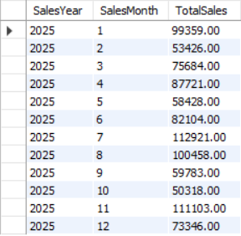

2. Percentage of canceled and returned orders per region.
SELECT
Region,
ROUND(
SUM(CASE WHEN OrderStatus IN ('Cancelled','Returned') THEN 1 ELSE 0 END) * 100.0
/ COUNT(*), 2
) AS Cancel_Return_Percentage
FROM RegionalSales2025
GROUP BY Region;
Output:
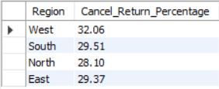
3. Identify 3 regions/products with most revenue loss (cancelled/returned).
SELECT
Region,
SUM(TotalAmount) AS RevenueLoss
FROM RegionalSales2025
WHERE OrderStatus IN ('Cancelled','Returned')
GROUP BY Region
ORDER BY RevenueLoss DESC
LIMIT 3;
Output:
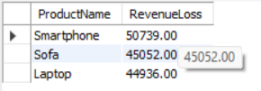
4. Average order value by product category.
SELECT
Category,
ROUND(AVG(TotalAmount),2) AS AvgOrderValue
FROM RegionalSales2025
WHERE OrderStatus = 'Completed'
GROUP BY Category
ORDER BY AvgOrderValue DESC;
Output:
Output:
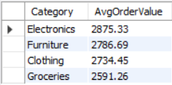

5. Top 5 performing sales agents (by completed revenue).
SELECT
SalesAgent,
SUM(TotalAmount) AS CompletedRevenue
FROM RegionalSales2025
WHERE OrderStatus = 'Completed'
GROUP BY SalesAgent
ORDER BY CompletedRevenue DESC
LIMIT 5;
Output:
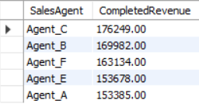

6. Category-wise total sales and contribution to grand total.
WITH CategorySales AS (
SELECT
Category,
SUM(TotalAmount) AS TotalSales
FROM RegionalSales2025
WHERE OrderStatus = 'Completed'
GROUP BY Category
)

SELECT
Category,
TotalSales,
ROUND(TotalSales * 100.0 / SUM(TotalSales) OVER(), 2) AS ContributionPercent
FROM CategorySales
ORDER BY TotalSales DESC;
Output:
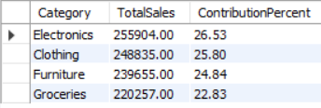
7. List customers with highest frequency of returns (≥ 3 times).
SELECT
CustomerID,
COUNT(*) AS ReturnCount
FROM RegionalSales2025
WHERE OrderStatus = 'Returned'
GROUP BY CustomerID
HAVING COUNT(*) >= 3
ORDER BY ReturnCount DESC;
Output:
